Dent-X Canada 311 Bowes Road
Phone: 416-774-2476
Email Address: info@dent-xcanada.com
City: Vaughan

CUSTOMER SITE SURVEY REPORT
ID:9677 |  | DATE: 2025-10-14
Customer Name: Dr. Arsalan Poorsina
Address: 1314 Upper Wentworth Street
City: Hamilton | State: Ontario |  | Poster Code: L9B 2H3
SURVEY DETAILS
Hello Team, after completing the site survey at 1314 Upper Wentworth Street I have identified some issues that will need to be addressed. It looks as if this office has not always been 8 ops total, and additional rooms were converted into Ops after the office was open for quite some time. After doing my initial site survey and looking into the walls, I have discovered that most of the rooms do not have lead shielding for X-ray equipment operations. If I had to guess, I would say that originally these rooms were approved on outdated ministry requirements where the rules on lead requirements in the walls were not as strict as they are today. So, the existing shielding in the rooms would only have needed to be updated if they were attempting to install newer units, as in the case of OP8
Please see below for more details about each room.

A = Air
W = Water
V = Vaccume

OP1

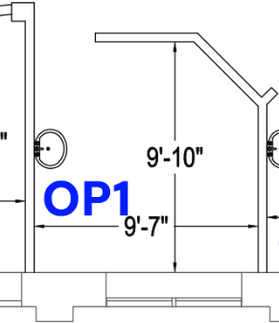

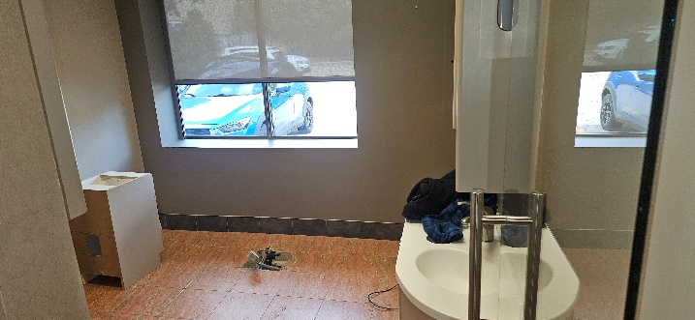  A W V | 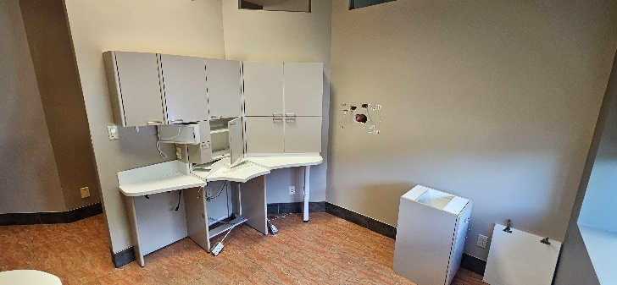
OP1 Has a char floor dilivery system which has the follow hookups available
Air
Water
Vacume
No Drain
This room can support a standard chair with no cuspitor attached, as the room does not have a drain connection.
Also note that this room would require an electrician to install an electrical outlet if they would like a TV in the OP

Note: I was unable to find lead in the walls of this room, to meet current ministry requirements for a intraoral X-ray unit, this room would require lead lining to be installed on the North East and West Walls.

OP2

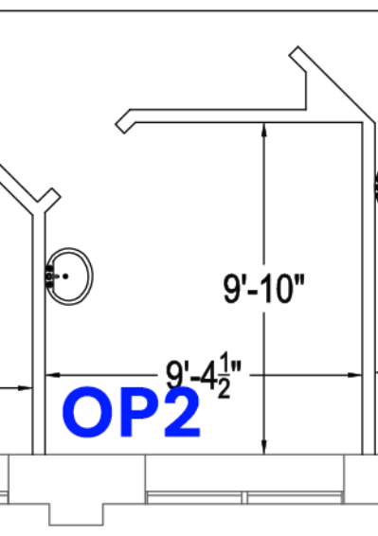

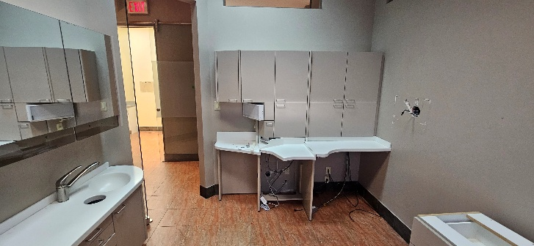  A W V | 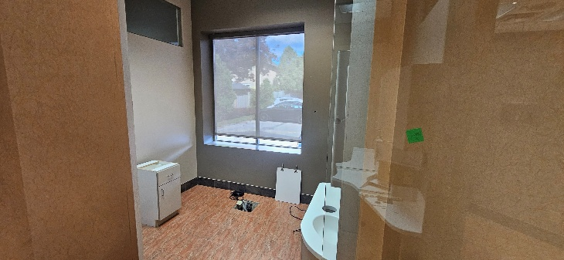  A W V
OP2 Has a char floor dilivery system which has the follow hookups available
Air
Water
Vacume
No Drain
This room can support a standard chair with no cuspitor attached, as the room does not have a drain connection.

Also note this room looks like it has the set up of Air, Water, Vacume located under the desk so it could also be set up for a rear dilivery system.

Also note that this room would require an electrician to install an electrical outlet if they would like a TV in the OP

Note: I was unable to find lead in the walls of this room, to meet current ministry requirements for a intraoral X-ray unit, this room would require lead lining to be installed on the North East and West Walls.

OP3

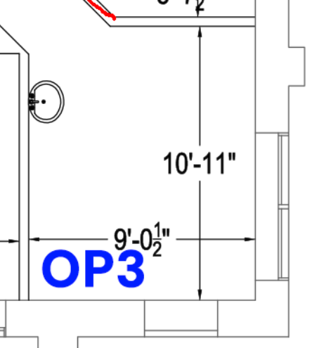

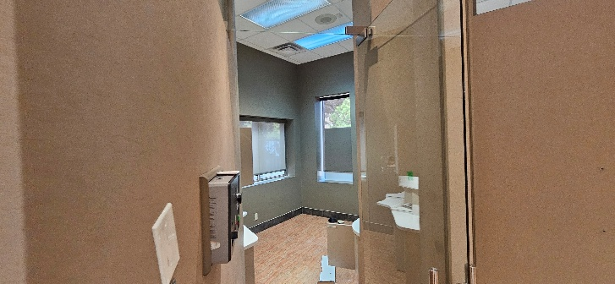  A W V | 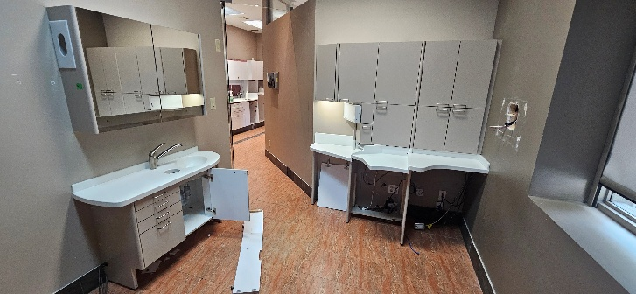  A W V
OP3 Has a char floor dilivery system which has the follow hookups available
Air
Water
Vacume
No Drain
This room can support a standard chair with no cuspitor attached, as the room does not have a drain connection.

Also note this room looks like it has the set up of Air, Water, Vacume located under the desk so it could also be set up for a rear dilivery system.

Also note that this room would require an electrician to install an electrical outlet if they would like a TV in the OP

Note: I was unable to find lead in the walls of this room, to meet current ministry requirements for a intraoral X-ray unit, this room would require lead lining to be installed on the North and West Walls.

OP4

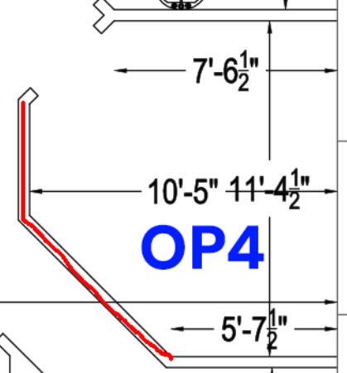

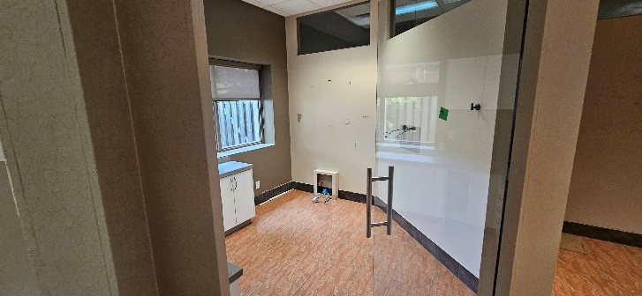  A W V | 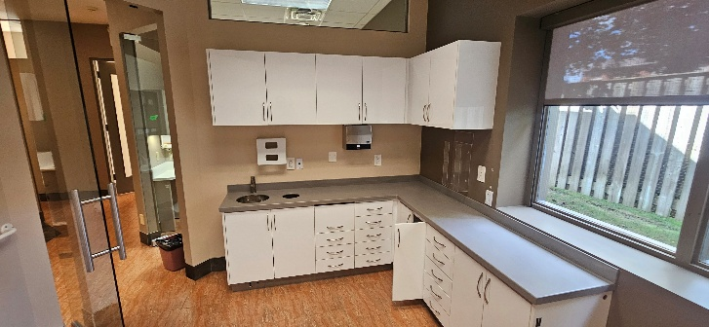
OP4 Has a wall mounted dilivery system which has the follow hookups available
Air, Water, Vacume , No Drain

This room can support a standard chair with no cuspitor attached, as the room does not have a drain connection. For a chair to work in this room, we would need to get a chair with an extended umbillical cord (The length of lines going from the chair to the connections for Water, Air, Vaccume, and power )

This looks like a room that was never intended to be set up as an OP, and they split the Air, Vacume, And Water from OP3

Also note that this room would require an electrician to install an electrical outlet if they would like a TV in the OP

Note: This op has limited lead on the West Wall only for a intraoral X-ray unit, this room would require lead lining to be installed on the North and South Walls.

Note2: The cabinets in the room already look like they are relatively new compared to the cabinets in the other ops, So you may be abel to get away with the exisiting cabinets in the ops.

OP5

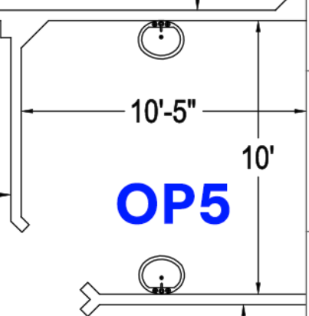

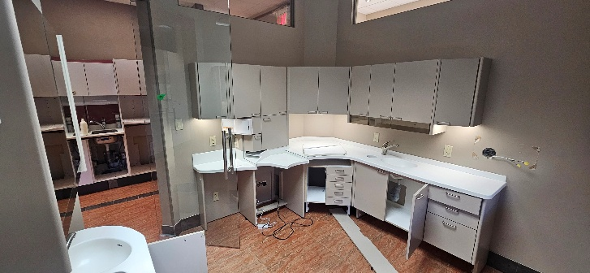  A W V | 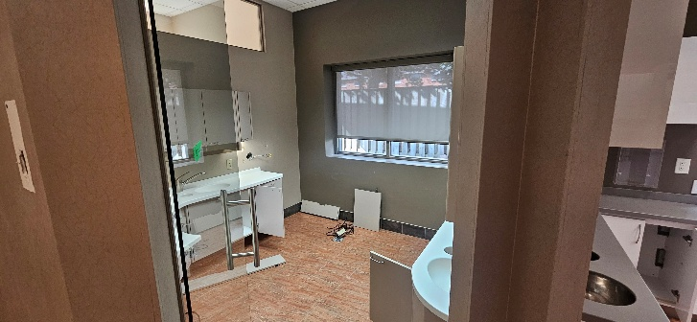
OP5 is set up for Rear Dilivery system only.
Air, Water, Vacume , No Drain

This room can support a standard chair only with no dilievry system or cuspitor

This room looks like it has the set up of Air, Water, Vacume located under the desk so it could be set up for a rear dilivery system.

Also note that this room would require an electrician to install an electrical outlet if they would like a TV in the OP

Note: Could not find any Lead in the walls of this room, Lead lining would need to be added to the North, South, and West walls.

OP6

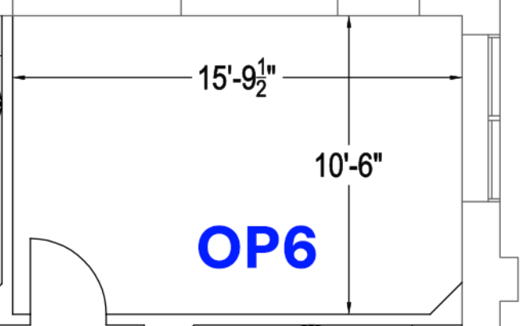

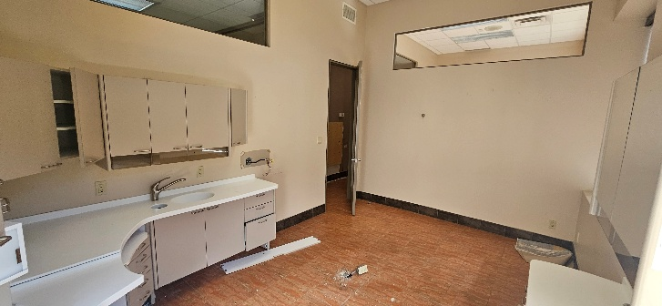 | 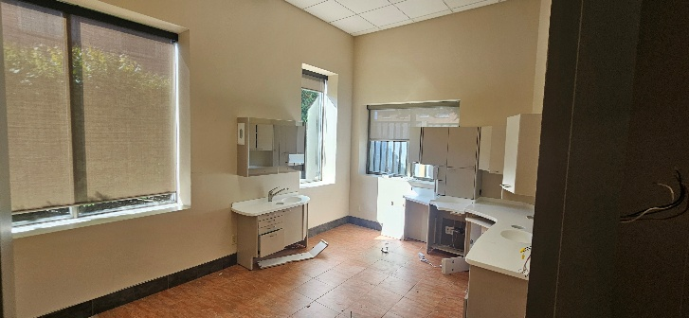  A W V
OP6 is set up for Rear Dilivery system only.
Air, Water, Vacume , No Drain

This room can support a standard chair only with no dilievry system or cuspitor.

This room looks like it has the set up of Air, Water, Vacume located under the desk so it could be set up for a rear dilivery system.

Also note that this room would require an electrician to install an electrical outlet if they would like a TV in the OP

Note: Could not find any Lead in the walls of this room, Lead lining would need to be added to the North, South, and West walls.

OP7

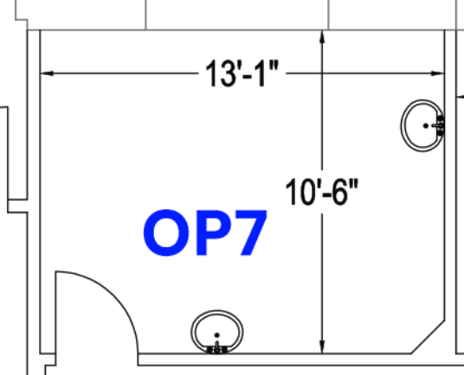

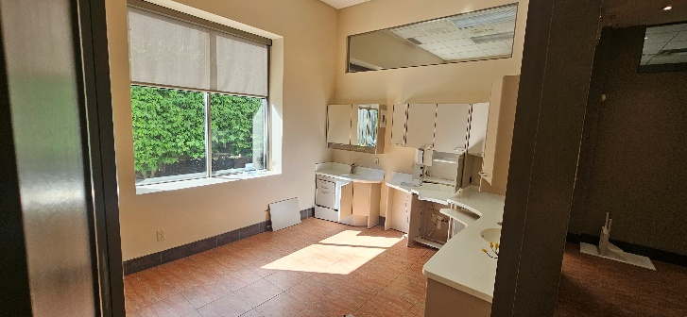 | 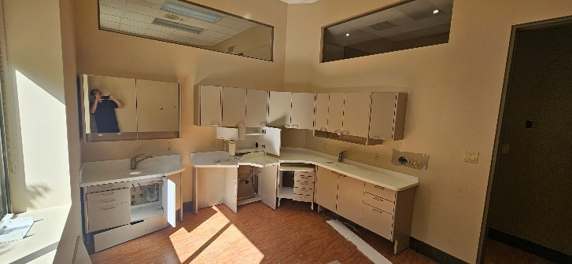  A W V
OP7 is set up for Rear Dilivery system only.
Air, Water, Vacume , No Drain

This room can support a standard chair only with no dilievry system or cuspitor.

This room looks like it has the set up of Air, Water, Vacume located under the desk so it could be set up for a rear dilivery system.

Also note that this room would require an electrician to install an electrical outlet if they would like a TV in the OP

Note: Could not find any Lead in the walls of this room, Lead lining would need to be added to the East and South walls

OP8

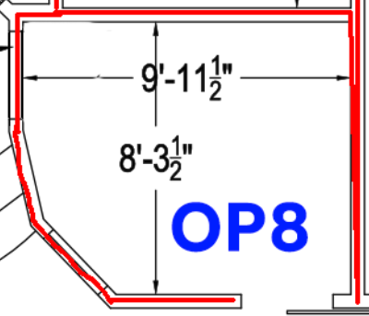

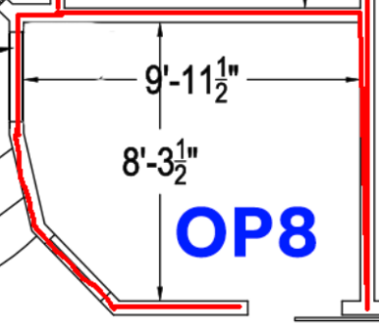
A W
OP8 looks like it was added after the fact and ONLY AIR AND WATER exisit in this room. My opinion is they never added a Vaccume line to this room, as it would require a plumber to make a trench in the floor the tie into the office vaccume system.

This Room has sufficient Lead Lining for an intraoral X-ray Machine

Sterilization Area

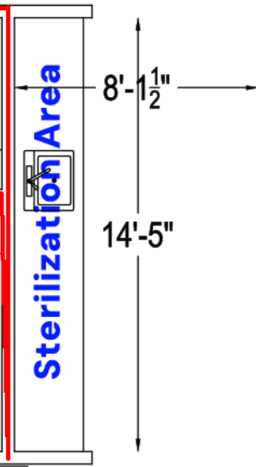

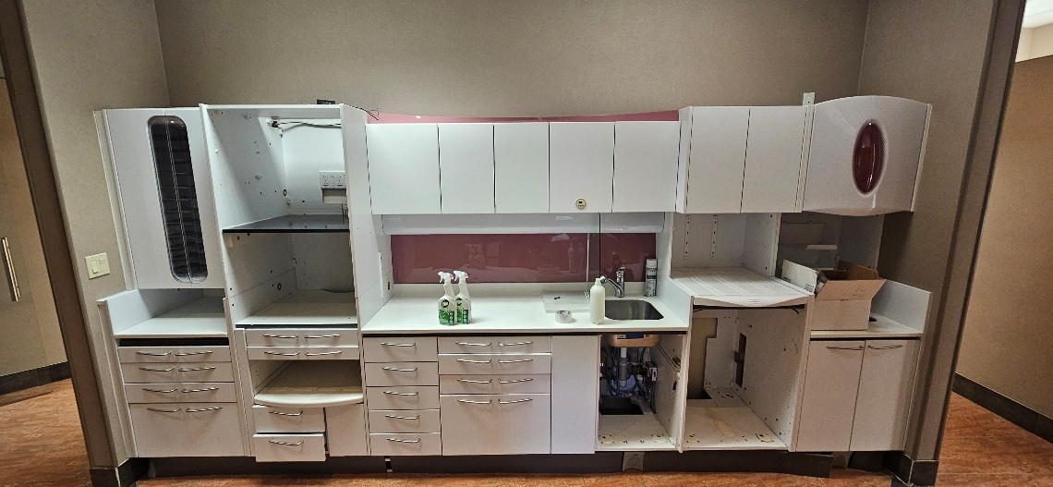
The Sterilization area is a good space. Has lots of electrical options for Steralizers Units. Depeninng on how the office wants this set up it, may requrie electrician to move outlets around.

Depending on what the office picks for options, and layout Plumber may be required to add/move plumbing connections.

Utility Room (Compressor, Vacuum, Amalgam Separator Area)

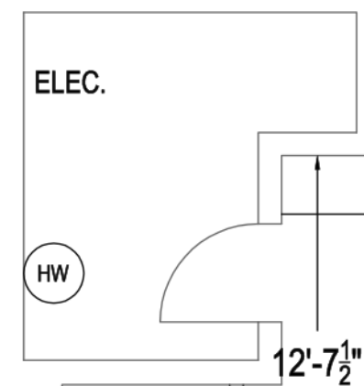

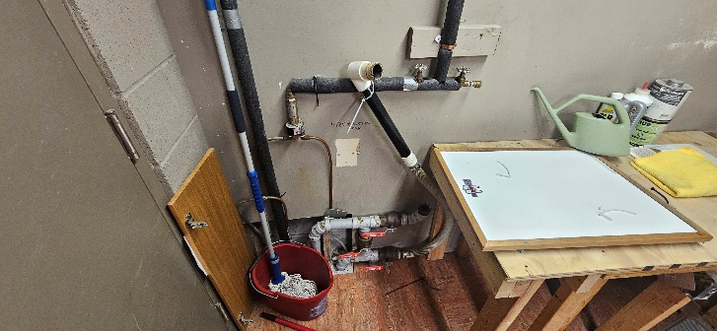 | 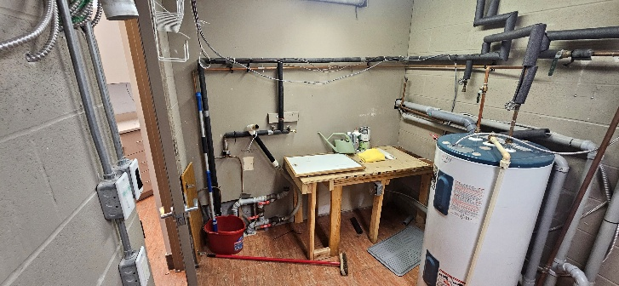
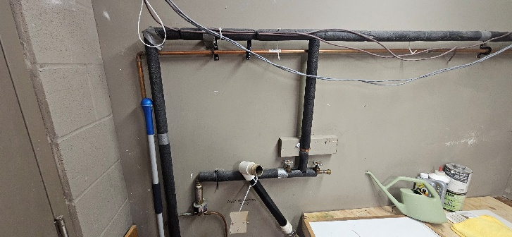 | 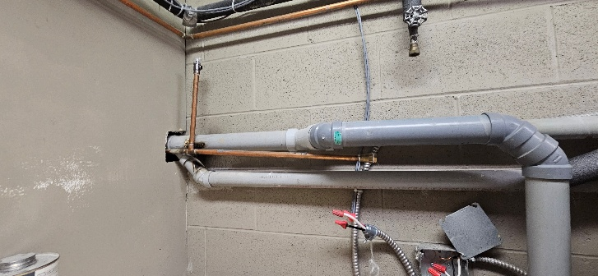
The Compress, Vacume, Amalgam seperator room has a decent layout. This location is better set up for a Wetvac system and not a Dry vac system.

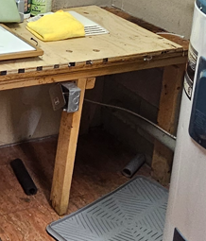
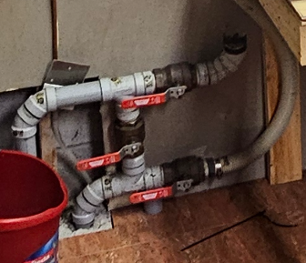
The plumbing in this room also leave some questions to be answered, I do not see an obvious drain for the Vaccume unit to connect too. I see this connection here, which looks like either they have 2 separate vacume line turnks, or one is vacume and one is drain, but what is throwing me off is the valve system that links both trunks or isolates them.

Also I do see a line running over here witch may be a Drain hookup for the Vacume unit.

Summary

After identifying a few issues here, we will also need to confirm with the Doctor where he wants the new equipment to be located as far as X-Rays, Computers, Cabinetry.

An electrician will also be required onsite to verify the electrical for the Intraoral X-rays are working, and running at the correct Voltage, as well as verify we have the correct electrical in the utility room to support a Compressor and Vacuum unit.

A Plumber will also be required to do an inspection of the Dental plumbing in the office, as when looking at the various areas in the ops to connect chairs / rear delivery systems I did notice that some of the fittings, and connection points are in poor condition / and broken. As well as to verify what is going on in the Utility room as far as Drain and vacuum hookup points are concerned.

